**GEOCARB_NET: Get STARTED**

* *Make a sub-directory named c:\Geocarb_Net (unless existing already)*
* *Download "Geocarb_Net.ZIP" from the link below:*

<http://www.planetaryhabitability.org/Software/Geocarb_Net.zip>

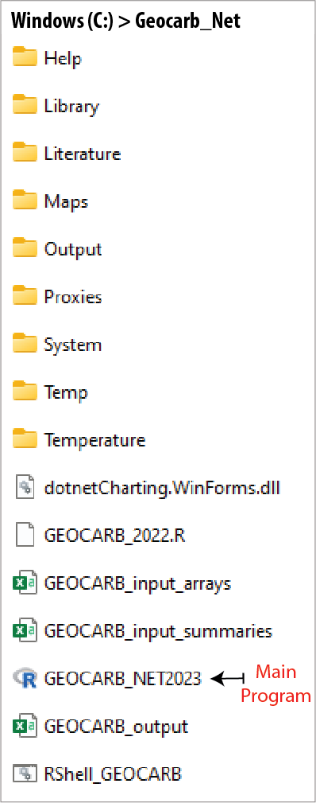The ZIP file is usually downloaded/stored on ‘Downloads’ and click on the ZIP file (or ‘Open file’), select all the files and sub-directories, and copy them to c:\Geocarb_Net’. When installed the sub-directory structure and files should look like the picture to the left.

* *Run the main program by clicking ‘GEOCARB_NET2023’* [right-click *'Pin to Start'* or *'Add to Favorites'* to start later]

When starting the program (security reasons), the windows system may warn you not to ‘Run File’. Click on ‘Info’ and a new message will appear and the click *‘Run anyway*’. This will only happen once.



**CONFIGURE the system**

Before you can operate the software you must install R on your computer.

* *In the program select ‘Organize’ and Configure’ and type the 'Location of R' (i.e., location of R.exe) in the text box*.

‘c:\program files\r\r-4.2.3\bin\r.exe’ is the default location when downloading R but this may require administrative password, so you could put R somewhere else and the configure the system.

* *You can also locate R.exe by clicking ‘Find Folder for R.EXE (modifies .BAT script)*’
* *When you have located R.exe then click 'Save Changes in R.EXE location'.*

This will modify and save a vital Windows Batch File (RShell_GEOCARB.Bat) that allows GEOCARB_NET to communicate with the R code where the actual carbon cycle modeling is undertaken. YOU ARE NOW READY TO OPERATE THE PROGRAM